Table of Contents

Abstract……………………………………………………………………………………...v

Acknowledgement …………………………………………………………………...…….vi

Description of company / organization……………………………………………………vii

Chapter 1 Introduction……………………………………………………………………..1

1.1 Overview of Project

1.2 Objective

1.3 Scope

1.4 Roles and Responsibilities

1.5 Project Plan (Week wise

Chapter 2 System Analysis………………………………………………………………….4

2.1 Study of existing system &amp; its limitations

2.2 Requirement of new system

2.2.1 Functional Requirements

2.2.2 Non-functional Requirements

2.3 Hardware Requirements

2.4 Software Requirements

Chapter 3 System Design…………………………………………………………………….8

3.1 Use case Diagram

3.2 E-R Diagram

3.3 Database design (Data Dictionary)

3.4 Modules of New System

3.5 System Flow Diagram

3.6 Input/output and Interface Design (Sample of Forms, Reports and Interface)

Chapter 4 Implementation Details…………………………………………………………13

Chapter 5 Testing……………………………………………………………………………19

Chapter 6 Conclusion and Future Work…………………………………………………..21

References……………………………………………………………………………………22

**ABSTRACT**

The website under consideration serves as a comprehensive platform designed to manage user registration, user login, and admin functionalities. The system entails three primary modules, namely User Registration, User Login, and Admin Login, each playing distinct roles in ensuring seamless user interactions and administrative control.

The User Registration module is responsible for collecting essential user information, including a unique registration number, first name, middle name, last name, gender, contact number, email address, password, and a confirmation of the password. It employs stringent validation protocols to ensure the accuracy and security of user-provided data. Moreover, it enforces a strict prohibition on the registration of users with existing email addresses in the database, safeguarding against duplicate entries.

The User Login module extends the user's experience by enabling them to access their profile and offers them the ability to update their registered details as needed. Additionally, users have the option to change their password securely. The module further facilitates the booking of hostel accommodations, where users input parameters such as member sharing preferences, the start date of their stay, the total amount paid, emergency contact information, guardian details, and address specifics. An integral component of this module allows users to view the room allocation provided by the admin.

The Admin Profile module is designed exclusively for administrators, granting access to confidential username and password management. Admins can modify their passwords as required to maintain system security. This module further includes a Courses Management section, affording administrators the capability to add or remove courses as needed. The room management feature allows admins to control room allocation and availability. An additional functionality within the Admin Profile module enables administrators to monitor user access logs, ensuring a transparent view of user activity.

The website as a whole offers a secure and user-friendly interface for individuals seeking to register and access hostel accommodations, and for administrators overseeing the system. With robust validation mechanisms, secure profile management, and granular control over course and room management, the website effectively serves its purpose, enhancing the user experience and streamlining administrative operations.

**ACKNOWLEDGEMENT**

I would like to extend my heartfelt gratitude to Crown Software for providing me with the incredible opportunity to serve as an intern in the "MD Hostel" project. This experience has been immensely enriching and transformative, and I owe this privilege to their unwavering support and mentorship. Crown Software, the company that made this internship possible, has proven to be an outstanding host for this endeavor. Their commitment to innovation and their contributions to the field are truly commendable, and I feel honored to have been a part of their team during this internship.

Dr. Amit Thakkar's guidance has been a constant source of inspiration and learning throughout this journey. His expertise, dedication, and unwavering commitment to fostering a conducive learning environment have been instrumental in my growth as a lab mentee.

Once again, thank you, Dr. Amit Thakkar Sir and Crown Software, for this incredible opportunity.

**Description of company / organization**



**Chapter 1 Introduction**

* 1. Overview of Project

The project is a web-based system with three main modules: User Registration, User Login, and Admin Login. In the User Registration module, users can sign up by providing their registration number, first name, middle name, last name, gender, contact number, email address, password, and confirm password. Comprehensive validation ensures data accuracy, and it prevents the registration of users with existing email addresses in the database.

The User Login module allows registered users to update their profile details, change their password, and book a hostel room by specifying various details such as member sharing, check-in date, total payment, emergency contact information, guardian details, address, and more. Additionally, users can view the room allocation assigned by the admin.

The Admin Profile module is confidential and accessible only to administrators. It enables the admin to manage their username and password securely, add or remove courses, and oversee room allocations. It also includes a user access log, providing insights into user activities.

In summary, the project is a comprehensive web application that facilitates user registration, login, and profile management, while granting administrators the tools to manage courses, rooms, and monitor user activities effectively.

* 1. Objective

The objective of the website is to provide a comprehensive and secure platform for user registration and management, catering to both regular users and administrators. It aims to facilitate a user-friendly registration process by collecting and validating essential information such as registration number, personal details, and contact information. The system prevents duplicate registrations with the same email address, ensuring data integrity.

For registered users, the website allows easy access through a login portal, where users can maintain their profiles, update information, and change their passwords as needed. Additionally, users can book hostel accommodations by specifying details like member sharing, check-in date, and emergency contact information. The website provides a seamless interaction between users and administrators, ensuring transparency in room allotment processes.

On the administrator's side, the website offers a secure login with confidential credentials. Administrators can efficiently manage courses by adding or removing them as required, providing flexibility in adapting to changing needs. Furthermore, administrators have access to a module for room management, streamlining room allocation procedures. The system also logs user activities, allowing administrators to monitor and maintain a record of user interactions.

Overall, the website's objective is to create a user-centric and efficient platform for user registration and management, while offering administrators the necessary tools to manage courses, rooms, and oversee user activities securely.

* 1. Scope

The scope of the website encompasses three main modules: User Registration, User Login, and Admin Login. The User Registration module allows new users to register by providing personal details with validations in place to ensure data accuracy. Duplicate registrations with existing email addresses are not allowed, ensuring data integrity. The User Login module provides users with a profile section for updating their registered information and changing their passwords. It also enables them to book hostels with relevant information such as member sharing, stay dates, payment details, emergency contacts, and guardian information. Additionally, users can view room allotments made by the admin. On the other hand, the Admin Profile module allows the administrator to manage courses and rooms dynamically. It also provides access to user activity logs for monitoring and ensuring security. Overall, this website facilitates user registration, profile management, hostel bookings, and admin-controlled course and room management while maintaining data security and validation.

* 1. Roles and Responsibilities

User Registration: The user registration module is responsible for enabling new users to sign up for the platform. It involves the collection of essential information, including registration number, first name, middle name, last name, gender, contact number, email ID, password, and confirmation of the password. The responsibilities include implementing rigorous data validation for each field to ensure the accuracy of user information. Additionally, it must check that a new registration isn't allowed with an existing user's email ID in the database.

User Login and Profile Management: This module is tasked with allowing registered users to access their accounts. It provides users with the ability to update their registered details, including personal information, and change their passwords as needed. Users can also use this section to book hostel accommodations, providing details such as member sharing preferences, check-in date, total amount paid, emergency contact information, guardian details, address, and more. Furthermore, the module allows users to view room allotment information provided by the admin.

Admin Profile and Management: The admin profile module serves as the control center for the website. The admin is responsible for maintaining the confidentiality of their username and password, with the ability to change their password when necessary. Additionally, the admin has the authority to manage courses by adding or removing them as needed. The module also allows the admin to oversee and manage hostel rooms. Furthermore, it provides access to user access logs, giving insight into user activity on the platform.

* 1. **Project Plan**

| **Week** | **Project Milestone** |
| --- | --- |
| 1 | Project initiation, team formation, and defining project scope. |
| 2 | Detailed requirements gathering and creating use cases for user registration. |
| 3 | Designing the user registration module, including database schema and validation processes. |
| 4 | Implementing user registration with email uniqueness checks and comprehensive data validation. |
| 5 | Designing the user login and admin login modules with secure access control. |
| 6 | Developing user login functionalities for profile updates and password changes. |
| 7 | Implementing admin login and adding basic admin features for username and password management. |
| 8 | Designing the room booking functionality and integrating it with user login. |
| 9 | Implementing user room booking capabilities, including member sharing and payment processing. |
| 10 | Admin module enhancement: adding course management and room allocation oversight. |
| 11 | Enhancing the admin module with a user access log for monitoring user activities. |
| 12 | Final testing, bug fixing, user acceptance testing, and project documentation completion. |

Chapter 2 System Analysis

2.1 Study of existing system & its limitations

The website consists of three main modules: User Registration, User Login, and Admin Login. Each module serves specific functions, but the existing system has several limitations that need to be addressed:

1. User Registration:

- Validation Constraints : The registration form includes various fields such as registration number, first name, middle name, last name, gender, contact number, email, password, and confirm password. While these fields are essential, the validation constraints need improvement to ensure data accuracy and completeness.

- Duplicate Email Check:** Although the system prevents new registrations with existing email IDs in the database, it may not handle cases where a user with the same name but a different email registers. This limitation can lead to potential data duplication.

2. User Login:

- Profile Update : The profile section allows users to update their registered details, but the system should ensure that changes are legitimate and secure.

- Password Change : While users can change their passwords, password management could be improved to encourage secure password practices and ensure the security of user accounts.

- Hostel Booking : The hostel booking module requires users to provide various details such as member sharing, stay start date, total amount paid, emergency contact, guardian information, and address details. The system should validate these inputs to prevent errors or incomplete submissions.

- Room Allotment : The description mentions that there is a section where admin allots rooms to users, but the details of this process are not provided. Clarity is required on how this function operates.

3. Admin Profile:

- Password Management : The admin's ability to change the password is a critical feature. However, security measures to protect this information should be robust, and it is essential to ensure that only authorized individuals can access the admin profile.

- Course Management : The admin has the capability to add and remove courses as needed. However, it's important to consider user-friendly interfaces and data integrity, as well as user access restrictions for this feature.

- Room Management:Managing rooms is an important administrative function. The system should provide efficient tools for handling room allocation, tracking room occupancy, and managing room-related data.

- User Activity Logs: The system's ability to access user activity logs is beneficial for tracking user actions. However, the report does not specify the level of detail or the retention period for these logs, which should be defined for compliance and auditing purposes.

Overall System Limitations:

- Security : The report does not elaborate on security measures to protect user data and sensitive admin credentials. Robust security mechanisms, including encryption and secure password practices, are crucial.

- User Experience: The usability and user-friendliness of the system are not discussed. Enhancements to the user interface and user experience should be considered to make the website more accessible and intuitive.

- Data Integrity: The report should address data validation and data integrity measures to prevent erroneous or incomplete data entry.

- Data Redundancy: The system should consider handling cases where users might have similar names but different email addresses to prevent data duplication.

In conclusion, the existing system has several limitations, primarily related to security, validation constraints, and user experience. Addressing these limitations is crucial for ensuring the efficiency, security, and usability of the website.

2.2 Requirement of new system

**2.2.1 Functional Requirements**

The functional requirements for the described website are as follows:

User Registration: Users can create accounts with unique registration numbers, providing their first name, middle name, last name, gender, contact number, email, and password. The system must validate the input data and prevent registration with an existing email address.

User Login: Registered users can log in, access their profile, update their details, and change their password. Users can also book hostel accommodations, specifying details such as member sharing, check-in date, total payment, emergency contact, guardian information, address, and city. The admin assigns rooms to users.

Admin Profile: The admin has a confidential username and password, allowing them to manage courses, including adding and removing courses. They can also manage hostel rooms. Additionally, the admin can access user activity logs to monitor user actions on the platform.

These requirements ensure secure and efficient user registration, user profile management, booking functionality, and admin control over courses, rooms, and user activity logs.

**2.2.2 Non-functional Requirements**

Security (The system must implement robust security measures to protect user data, ensuring encryption of sensitive information, and preventing unauthorized access or data breaches. Regular security audits and updates are required.) Scalability , Performance (The system should be responsive, with quick loading times for all pages and modules. It should have minimal downtime, ensuring a seamless user experience.), Availability (The website must be accessible 24/7, with a reliable hosting infrastructure and backup systems in place to ensure continuous service availability.) Usability (The user interface should be intuitive and user-friendly, making it easy for both users and administrators to navigate and perform tasks efficiently. Accessibility standards should also be followed for a diverse user base, Data Backup and Recovery (Regular data backups and a well-defined recovery plan should be in place to prevent data loss and enable quick recovery in case of system failures or data corruption) , Regulatory Compliance (The system must comply with relevant data protection and privacy regulations, such as GDPR, HIPAA, or other applicable laws, ensuring the security and privacy of user data) , Load Balancing (Load balancing mechanisms should be implemented to distribute user traffic evenly and prevent server overloads during peak usage times.)Logging and Monitoring: Comprehensive logging and monitoring should be in place to track user activities and system performance, aiding in troubleshooting and auditing, Cross-browser Compatibility (The website should function consistently across various web browsers and devices to ensure a broad user base can access and use the platform.)

2.3 Hardware Requirements

The hardware requirements include a web server capable of hosting and serving the web application. The server should have sufficient computing power and memory to handle concurrent user requests efficiently. Additionally, a database server is required to store and manage user data and records. The specific hardware specifications will depend on the expected traffic and usage patterns of the website. For optimal performance, it is advisable to use a server with multi-core processors and a sufficient amount of RAM to handle the web application's requirements. The database server should have enough storage space to accommodate user registration data and logs. It's essential to implement regular backups and redundancy for data security and fault tolerance. Moreover, ensuring adequate network bandwidth and a reliable internet connection is crucial for seamless user interactions and data exchange. Security measures such as firewalls and encryption protocols should be in place to protect user information and sensitive data. Routine maintenance and monitoring are also essential to keep the website running smoothly and securely. In conclusion, the hardware requirements for this website encompass a robust web server, a capable database server, sufficient storage capacity, network infrastructure, and security measures to deliver a secure and responsive user experience.

2.4 Software Requirements

User Registration Module: This module should include fields for registration number, first name, middle name, last name, gender, contact number, email ID, password, and confirm password. Implement strict validation rules for data entered, including email format, password strength, and unique email addresses in the database.

User Login Module: Upon successful registration, users should be able to log in and access a user profile section. This profile section should allow users to update their registered details, including personal information and password changes. Users should also be able to book hostel accommodations, specifying member sharing, check-in date, total payment, emergency contact information, guardian details, and address details. Additionally, a feature should allow users to view the room allotment assigned by the admin.

Admin Login Module: Admins should have a secure login, safeguarded with a confidential username and password. This module enables admin users to manage courses, with the ability to add or remove courses as needed. Admins should also be able to manage hostel rooms, assigning rooms to registered users. Additionally, there should be a user access log to monitor and audit user activities within the system.

Chapter 3 System Design

3.1 Use case Diagram

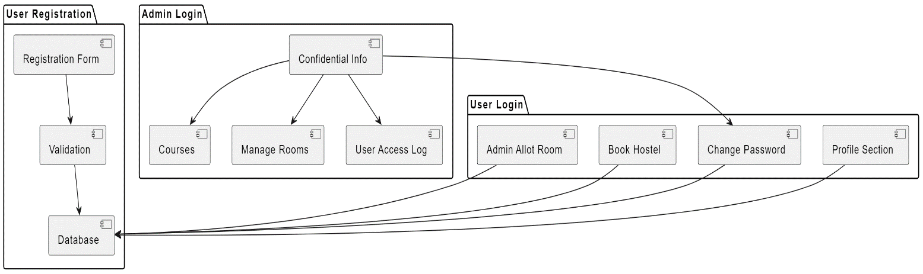

3.2 E-R Diagram

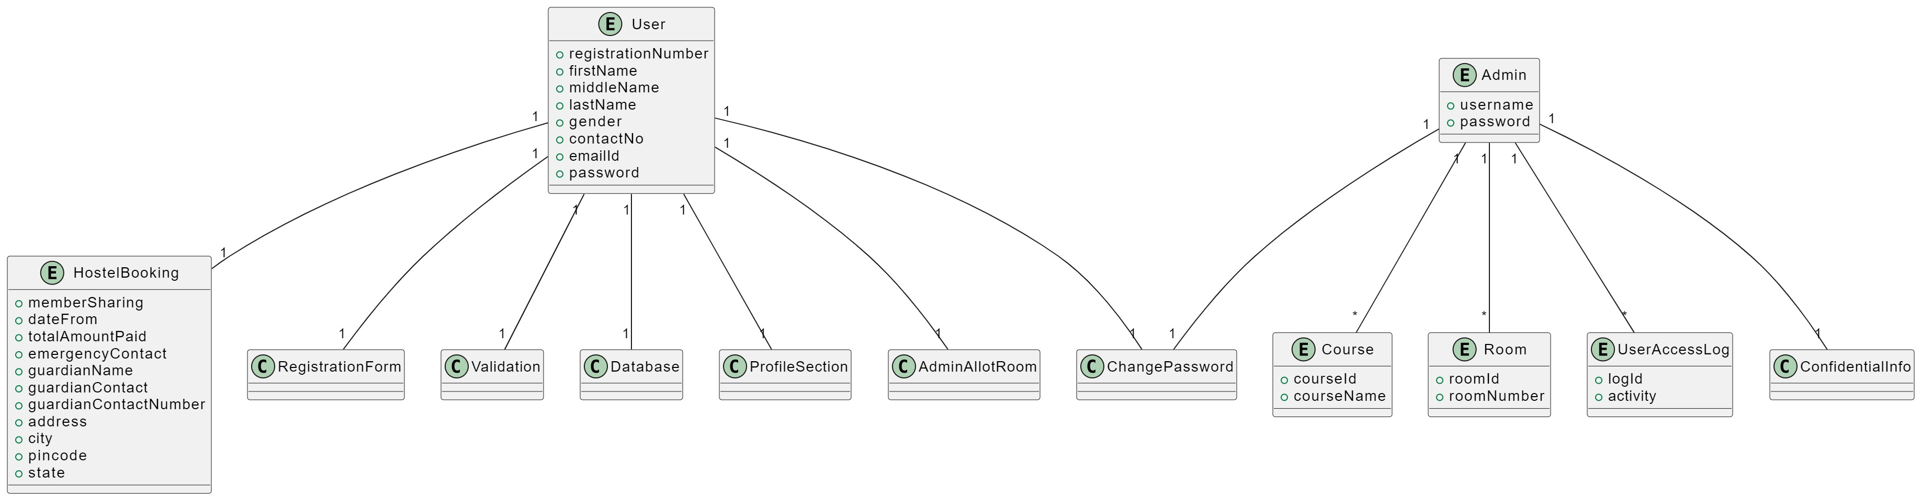

3.3 Database design (Data Dictionary)

1. User Registration Table (user_registration):

registration_id (Primary Key, first_name , middle_name, last_name, gender, contact_no, email_id (Unique), password, confirm_password

2. User Login Table (user_login):

user_id (Primary Key), registration_id (Foreign Key, linked to user_registration), member_sharing, stay_start_date , total_amount_paid, emergency_contact, guardian_name, guardian_contact, guardian_contact_number, address, city, pincode state , room_allotment (Foreign Key, linked to rooms table, if applicable)

3. Admin Profile Table (admin_profile):

admin_id (Primary Key), username, password

4. Courses Table (courses):

- course_id (Primary Key), course_name, course_description

5. Rooms Table (rooms):

- room_id (Primary Key), room_number, room_type, room_capacity, availability_status

6. User Access Logs Table (user_access_logs):

- log_id (Primary Key), user_id (Foreign Key, linked to user_login) , timestamp, activity_description

3.4 Modules of New System

User Registration: This module enables new users to register with the system. It collects essential information such as registration number, first name, middle name, last name, gender, contact number, email ID, password, and confirm password. The module includes robust validation checks and prevents the registration of users with existing email addresses in the database.

User Login and Profile Management: Users can log in using their registered credentials. Within this module, users can access their profiles, update their registered details, and change their passwords as needed. Additionally, users can book hostel accommodations, providing information such as member sharing preferences, check-in date, total payment, emergency contact details, guardian information, address, city, pincode, and state. It also includes a section where users can view room allotments made by the admin.

Admin Profile: The admin profile module is exclusive to administrators. It includes confidential username and password settings, allowing the admin to change their password as required. Furthermore, admins can manage courses by adding or removing them as necessary. The module also provides control over room management. Lastly, administrators can access user activity logs, gaining insights into user actions and system usage.

3.5 System Flow Diagram

1. user

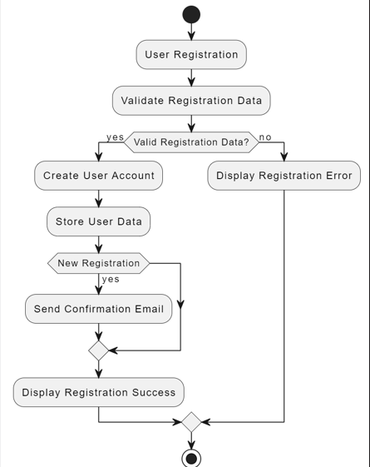

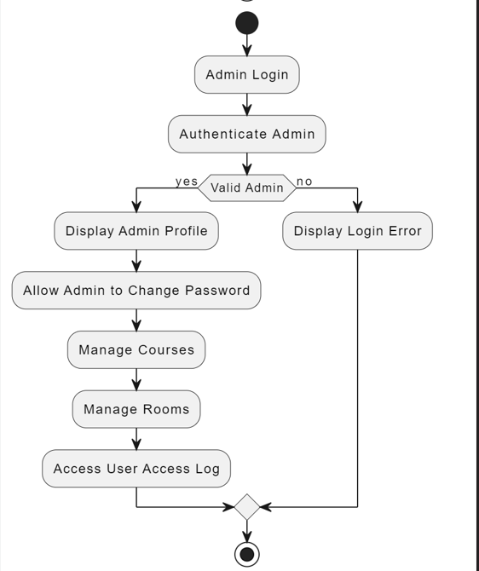

1. admin login

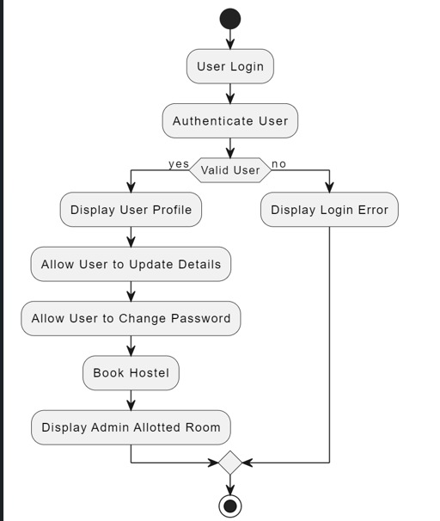

1. user login

Chapter 4 Implementation Details

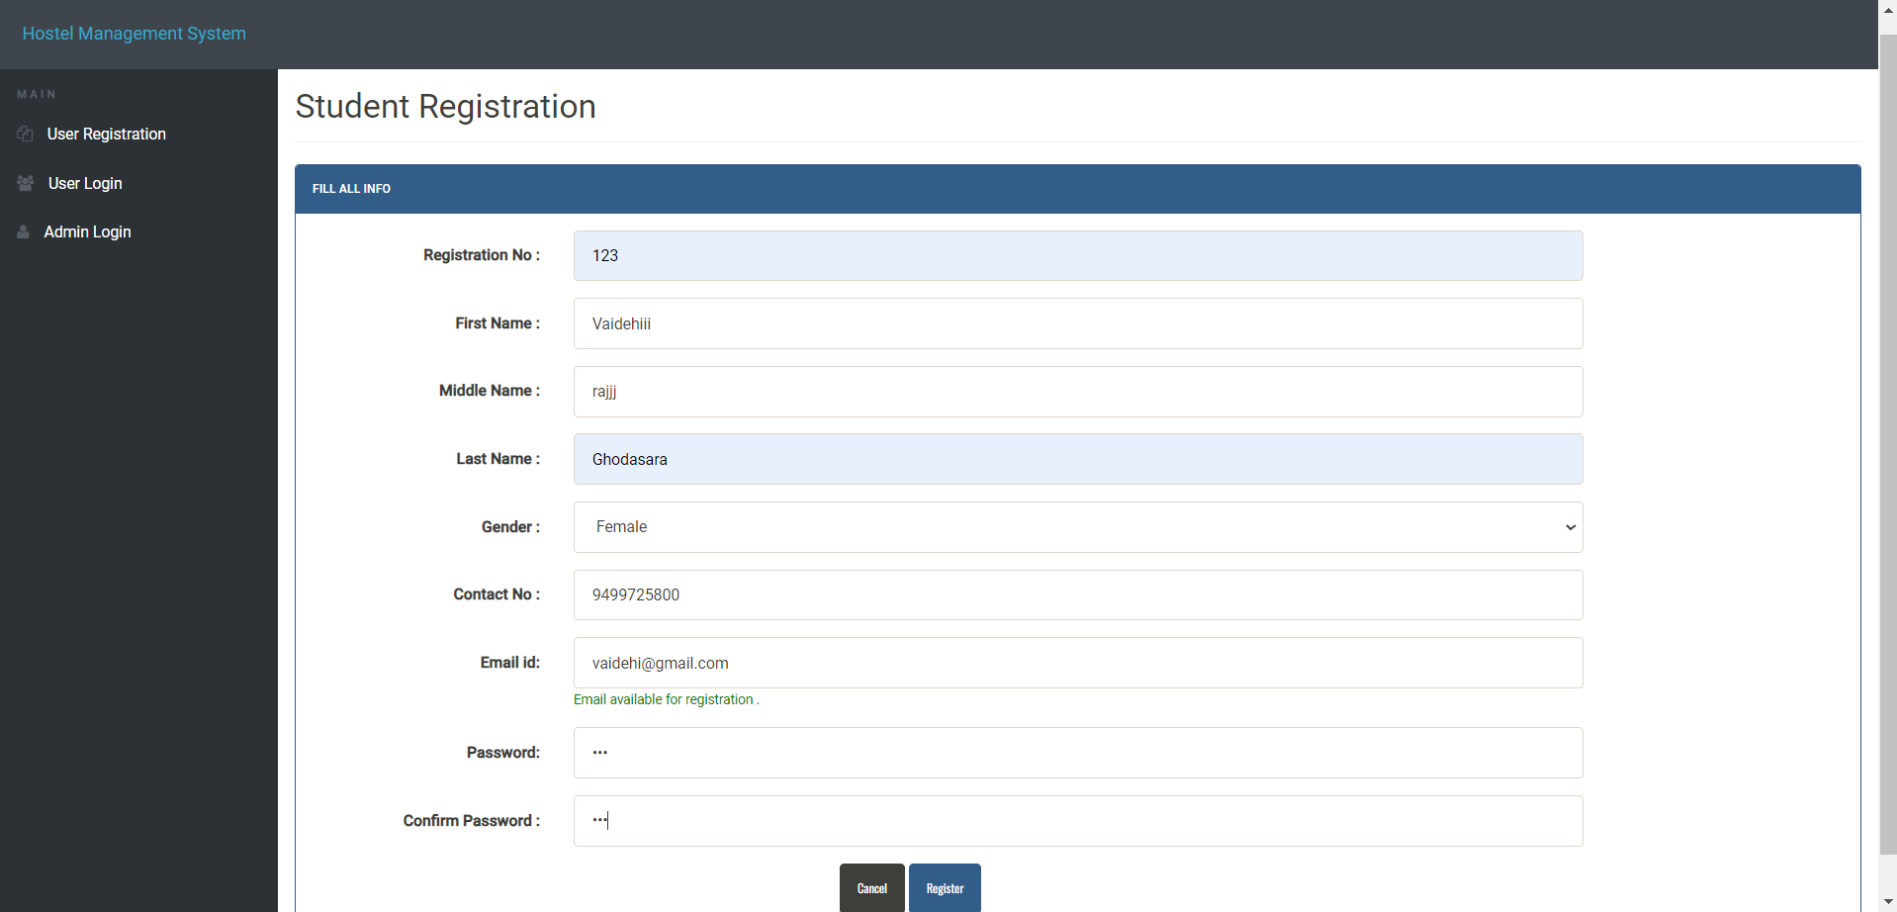

New user registration

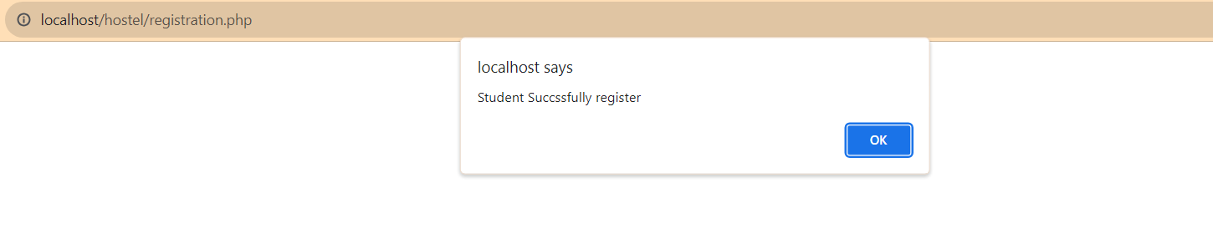

Registration Successful message

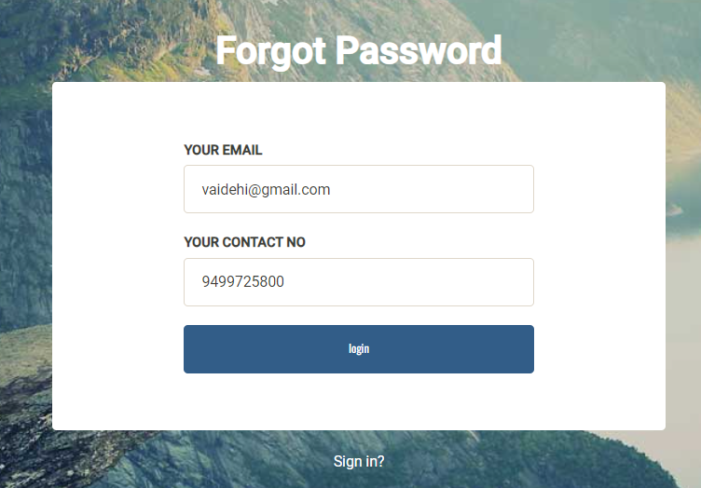

Forget Password (Register)

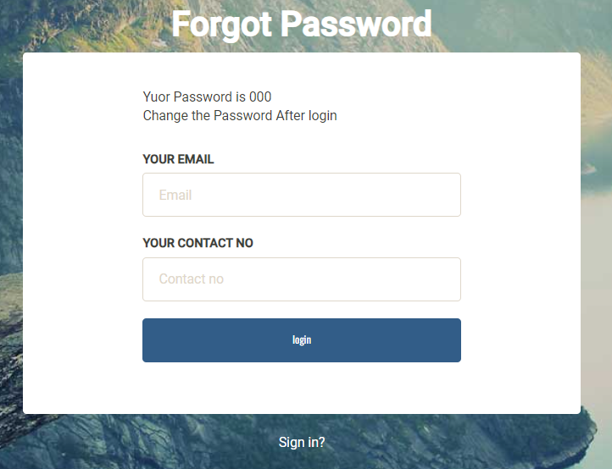

Password is shown

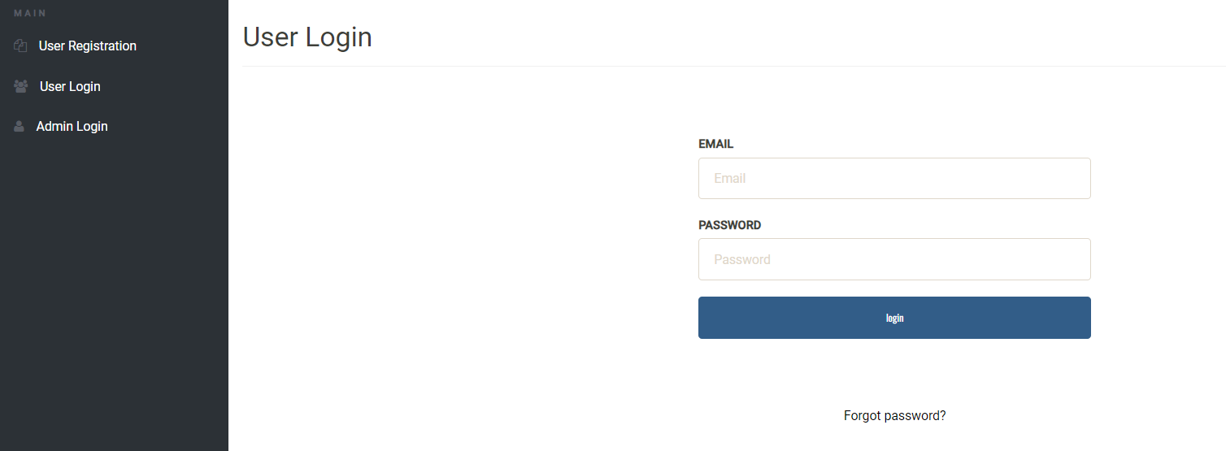

User login

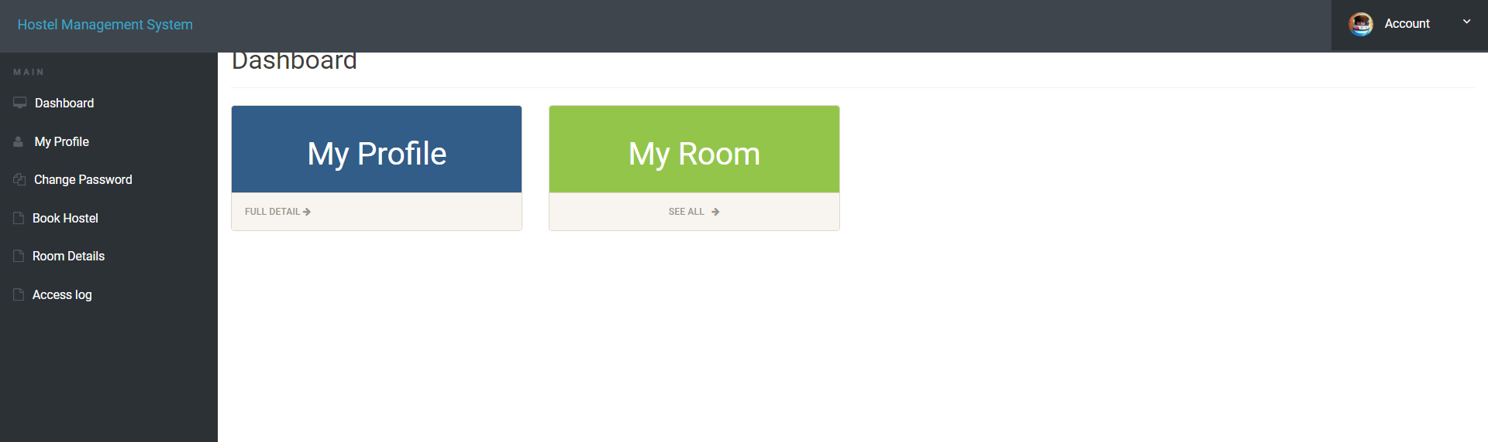

User Dashborad

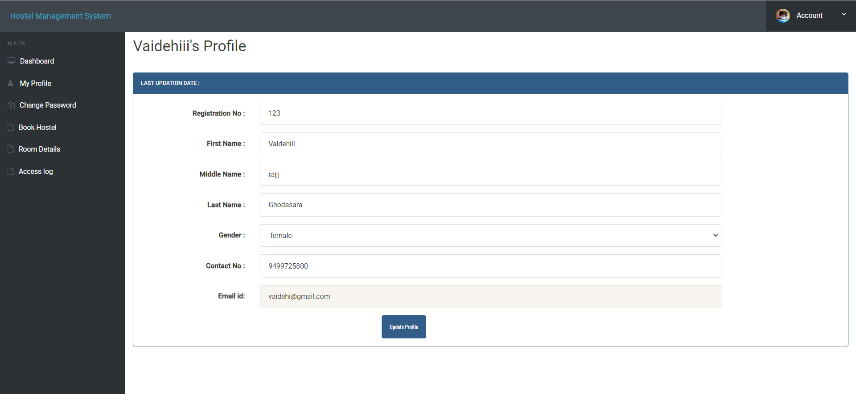

User profile update

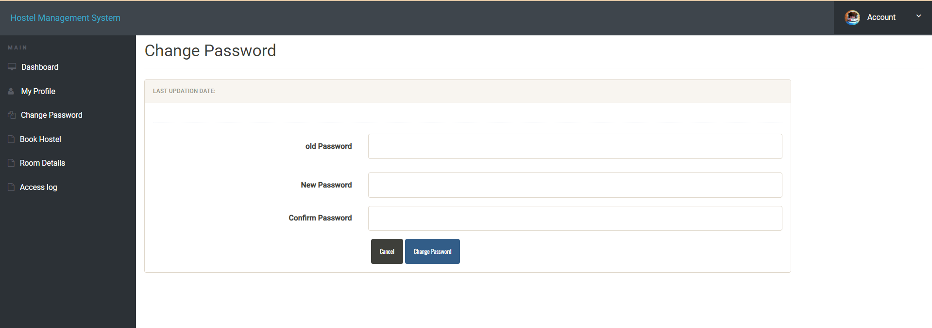

User can change password

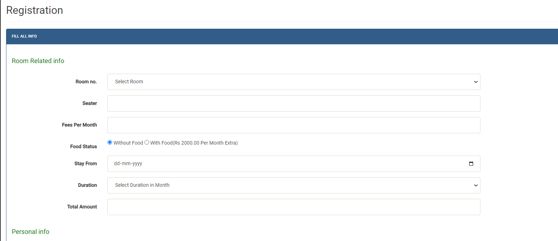

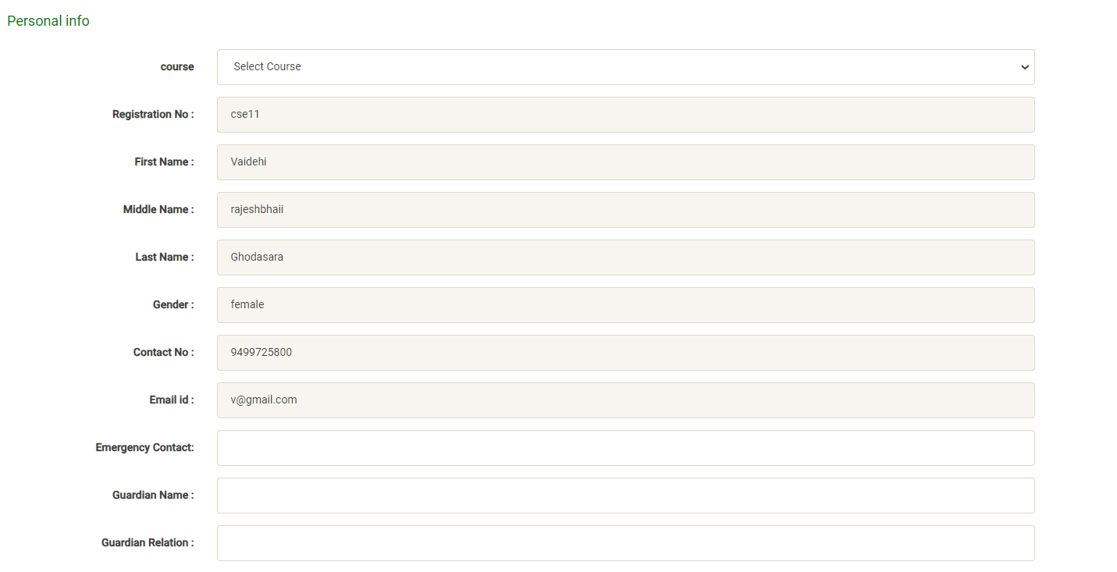

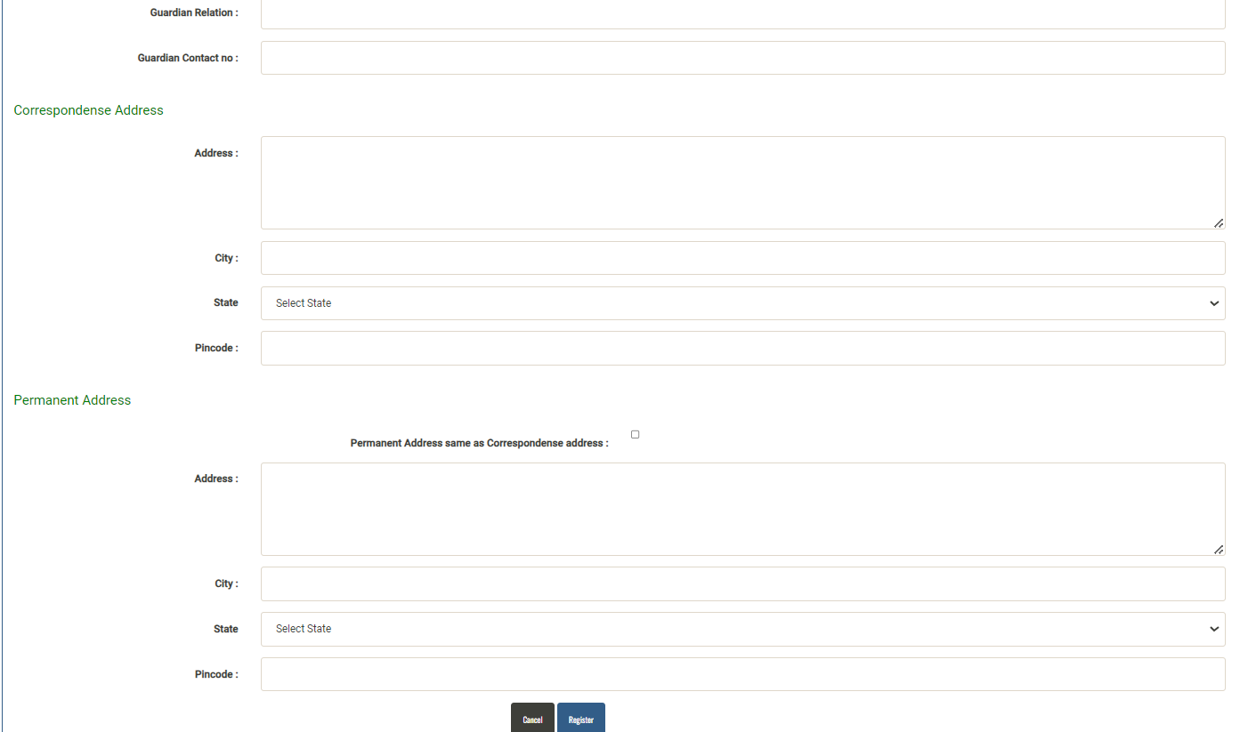

User registration form

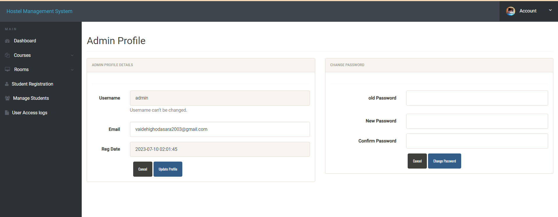

Admin dashboard

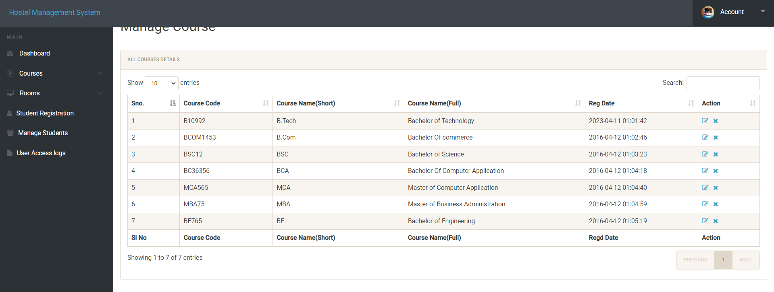

Existing Courses

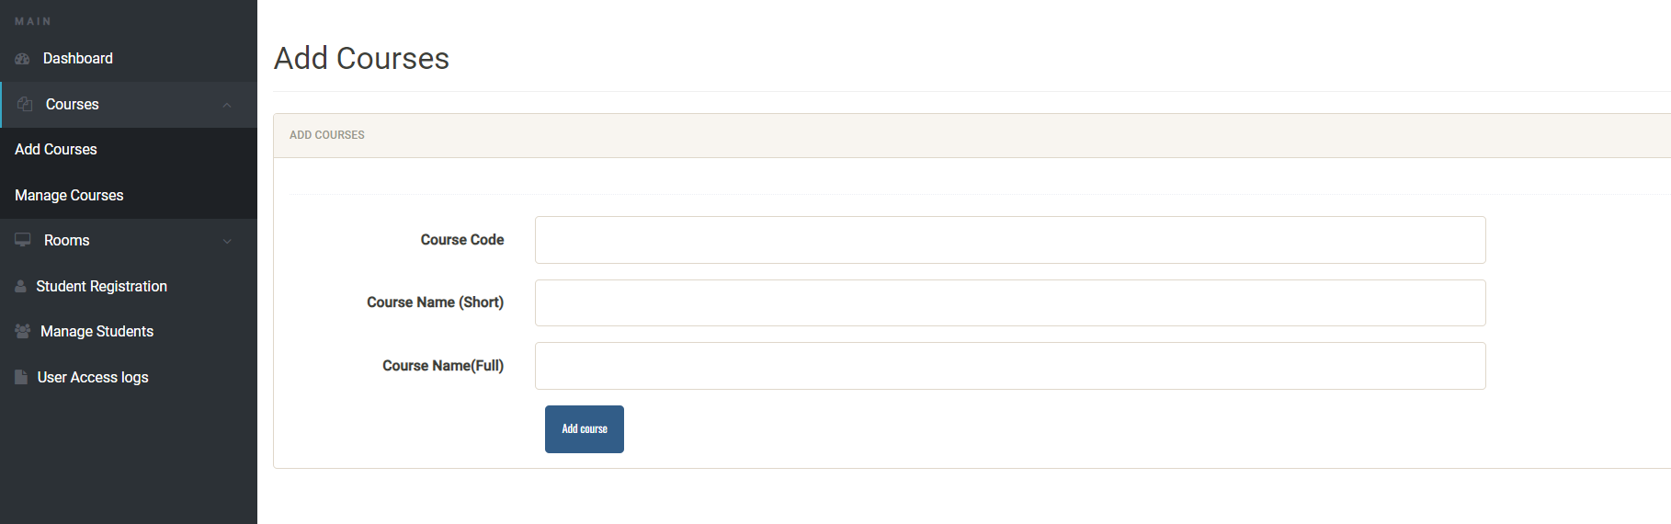

Admin can add courses as per requirements







Admin registors student directly

Chapter 6 Conclusion and Future Work

Conclusion :

The website is designed to facilitate user registration, user login, and admin login, with a focus on user management and hostel booking. The system includes robust validations to ensure data integrity and security. Key features include:

User Registration: Users can create accounts with their unique registration number, personal details, contact information, and secure login credentials. The system prevents duplicate registration with the same email address.

User Login: Once registered, users can access their profiles to update personal information and change their passwords. The system also allows them to book hostels, specifying details like member sharing, stay dates, payment, emergency contact, guardian information, and address details. Additionally, users can view room allotments.

Admin Profile: The admin has access to confidential login credentials and can change the password when necessary. They can manage courses, adding or removing them as needed. The admin can also oversee room management and access user activity logs.

**Future Work:**

Payment Integration: Integrate payment gateways to enable secure online payments for hostel and mess fess

User Reviews: Allow users to provide feedback and reviews for their hostel stay, which can help improve the quality of services.

Consider expanding the website's services beyond hostel bookings to include other student-related services, such as event registration or campus information.

References

<https://datatables.net/>

<https://www.w3schools.com/php/>

<https://www.w3schools.com/php/php_mysql_connect.asp>

<https://www.w3schools.com/bootstrap/>